Michela Mifsud

BA (HONS) IN interactive media

Year 2

Design Documentation

App Development

Bud

*BUD* is the tentative name of a student companion app that is going to be designed to make the student’s day to day life a bit easier than it is. It will have several uses, including the very useful calendar, that is sure to prevent students from forgetting about their upcoming assignments and a news feed that is used mainly by lecturers, to inform them if something happens (example: the lecture is cancelled).

Wireframe Flowchart

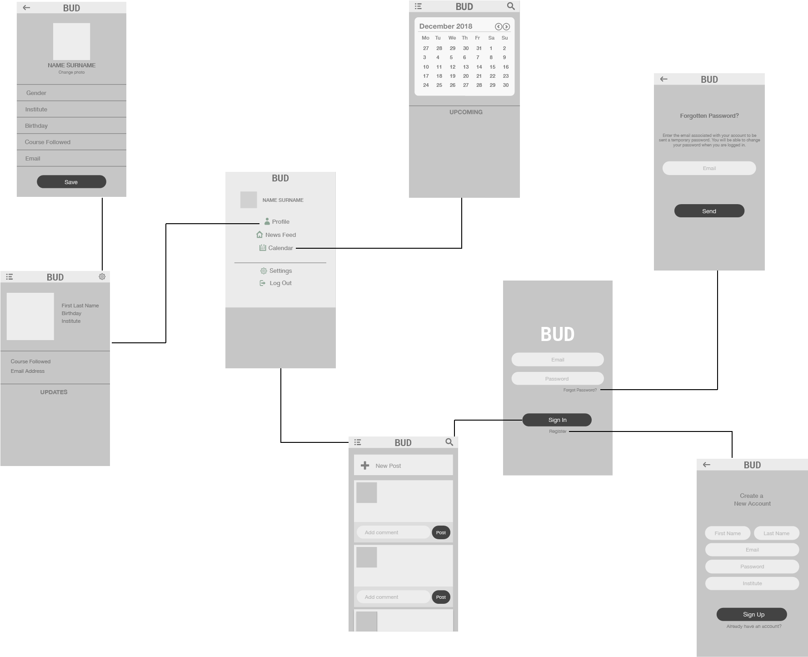

The Pages and respective functional features included are:

* Login Page
  + Forgotten Password button – will lead to the forgotten password page
  + Sign In button – will lead to the news feed
  + Register button – will lead to the registration page
  + Email & Password text inputs
* Forgotten Password Page
  + Email text input
  + Send Email Button – will send an email with a temporary password to the relative email address
* Registration Page
  + Text Inputs
  + ‘Already Have an Account’ button – will lead back to the login page
  + Sign Up button – will create the account and put it into the database, and lead to the news feed page.
* News Feed
  + Add Post – lets the user add a post to the news feed
  + Comment box – lets the user add a comment to an already existing post
  + Hamburger Menu
  + Search button – filters posts according to key words searched
* Calendar
  + Forward and Back buttons – lets user change months in calendar
* Profile
  + Settings button – will lead to the settings page
* Settings
  + Drop down selection – Gender
  + Text box inputs
  + Change photo button
  + Save button
* Drop Down Menu
  + Profile – leads to profile page
  + News Feed – leads to news feed
  + Calendar – leads to calendar page
  + Settings – leads to settings page
  + Log Out – logs out of session

IPO Charts

# Login Page

|  |  |  |
| --- | --- | --- |
| Input | Process | Output |
| Username | Check database for registered username and password | Go to news feed |
| Password |  |  |

# Registration Page

|  |  |  |
| --- | --- | --- |
| Input | Process | Output |
| First Name | Add new Profile to the database | Go to News Feed |
| Last Name |  |  |
| Email |  |  |
| Password |  |  |
| Institute |  |  |

# Settings

|  |  |  |
| --- | --- | --- |
| Input | Process | Output |
| Gender | Save changes to the profile and database | Go to profile page |
| Institute |  |  |
| Birthday |  |  |
| Course followed |  |  |
| Email |  |  |

# Forgotten Password

|  |  |  |
| --- | --- | --- |
| Input | Process | Output |
| Email address | Email is matched with records and if found, recovery email is sent | Go to login page |

# News Feed

|  |  |  |
| --- | --- | --- |
| Input | Process | Output |
| New Post | Add posts and comments to the news feed/database | Post/Comment shows up on news feed |
| Comment |  |  |

Style Guide

The main colour of the app that I have chosen is green. Studies have shown that green can help improve reading ability, and since the colour is associated with tranquility and good luck, and this will be a good thing to incorporate into the student companion app, for students who need to be a bit more tranquil and have a bit more luck in their life, as well as aid them whilst browsing through the application, to avoid eye-strain.

Pops of orange will be incorporated, especially with the calendar notifications, to capture the user’s attention. Orange was chosen because I didn’t want to go for the harshness of red, and orange goes well with the chosen green palette.

The main font used is going to be Helvetica Neue, with varying weights depending on the part of the application, whether it be a title, body text, notification. Meanwhile, the font used for the name of the application is Menlo Bold.

Buttons are rounded, while text input boxes are clear in background, but still has green incorporated, to keep up with the theme.



# References

Cherry, K., 2018. *The Color Psychology of Green.* [Online]   
Available at: https://www.verywellmind.com/color-psychology-green-2795817  
[Accessed 2018].